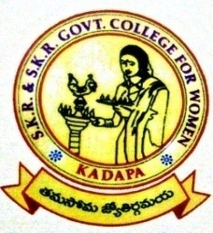
SKR & SKR GOVT COLLEGE FOR WOMEN (A) KADAPA
Lecturer Wise Result Analysis 2020-2021
Name of the Lecturer: P.LAVEENA
Designation: Guest faculty
Subject: BIOCHEMISTRY

Year | Sem | Paper | No of students Appeared | No of Students Passed | No of Students failed | Pass %
I BMC | I | Paper-I | 38 | 36 | 02 | 94.7
I BMC | II | Paper-II | 37 | 37 | 00 | 100
II BMC | III | Paper-III | 43 | 42 | 01 | 97.67
II BMC | IV | Paper-IV | 41 | 40 | 01 | 97.5
III BMC | V | Paper-V | 17 | 16 | 01 | 94.11
III BMC | V | Paper-VI  (Elective) | 17 | 17 | 00 | 100
III BMC | VI | Paper-VII | 17 | 17 | 00 | 100
III BMC | VI | Paper-VIII-A1  (Cluster) | 11 | 11 | 00 | 100
III BMC | VI | Paper-VIII –A2  (Cluster) | 11 | 11 | 00 | 100
III BMC | VI | Paper-VIII-A3  (Cluster) | 11 | 11 | 00 | 100

